EYFS LTP 2024-25
Including clear unit outcomes and grammar and punctuation to be taught at specific times throughout the year
Drawing Club approach used to achieve learning outcomes.
 | EYFS – Literacy Overview
 | AT1 |  |  |  |  | AT2 |  |  |  |  | Sp1 |  |  |  |  | SP 2 |  |  |  |  | SU1 |  |  |  |  | SU2
Focus EYFS Curriculum | To form the letters they are learning.  To begin to write their own messages using a range of letter like shapes and familiar letters. |  |  |  |  | To give meaning to their marks.  To make links between sounds learnt in phonics and the letters needed for writing.  To begin to write across the page.  To write using a wider range of letter strings. |  |  |  |  | To write simple words (e.g cvc words).  To learn letter formation families. |  |  |  |  | To write a wider range of words with more phonetic accuracy.  To begin to write simple sentences using their phonic knowledge and core words.  To read their writing back. |  |  |  |  | To write simple sentences with phonetic accuracy.  To begin to space words out on a page. |  |  |  |  | To begin to use capital letters at the start of their sentence and full stops at the end.  To begin to write more than one simple sentence.
 | Autumn 1 – Who are we?
DC for 2025   |  |  |  |  | DC Book: 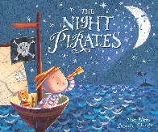 |  |  |  | DC Cartoon: Captain Pugwash |  |  |  | DC Book: 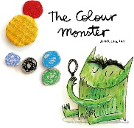 |  |  | DC Tale:  Hansel and Gretl |  |  |  | DC Book: 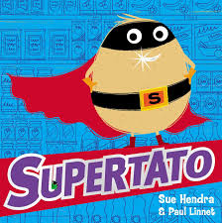 |  |  |  | DC Cartoon:  Bagpuss |  |  |  |  | DC Book: 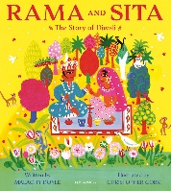
Supporting Texts | 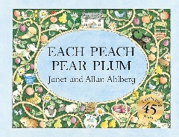 |  |  |  | 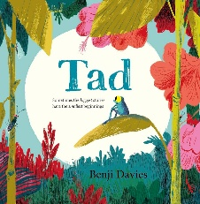 |  |  |  | 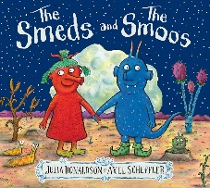 |  |  |  | 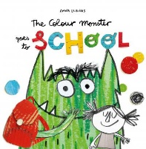 |  |  | 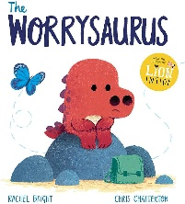 |  |  |  | 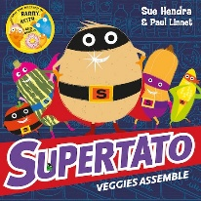 |  |  |  | 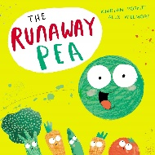 |  |  |  |  | 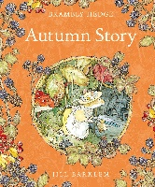
Autumn 2 – Who are we?
DC for 2025 | DC book: 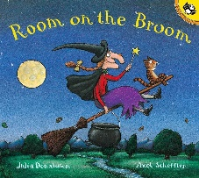 |  |  |  | DC cartoon:  Pink Panther |  |  |  | DC Book: 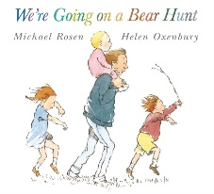 |  |  |  | DC Tale:  The Three Billy Goats Gruff |  |  | DC cartoon:  Roadrunner |  |  |  | DC Book:  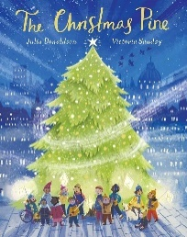 |  |  |  | DC Tale:  The Gingerbread Man |  |  |  |  | Whole school Poetry  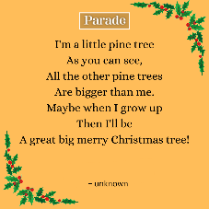
Supporting texts | 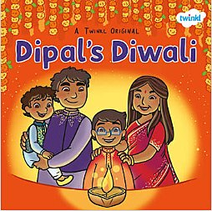 |  |  |  | 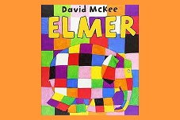 |  |  |  | 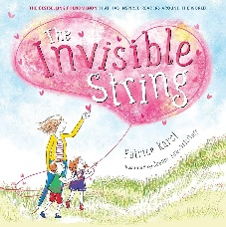 |  |  |  | 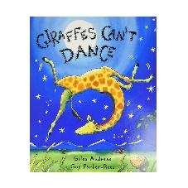 |  |  | 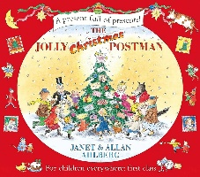 |  |  |  | 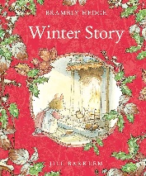 |  |  |  | 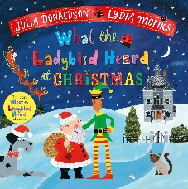 |  |  |  |  | 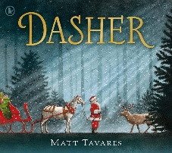
Spring 1 – Where are we?
English  Drawing Club |  |  |  | What is a sentence?  DC Book: 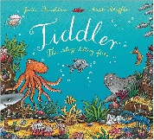 |  |  |  | DC Tale: The Three Little Pigs |  |  |  |  |  | DC Book:  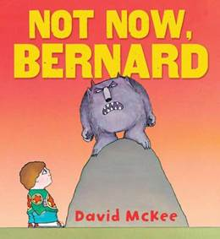 |  |  | DC Cartoon: Trapdoor |  |  |  |  | DC Book: 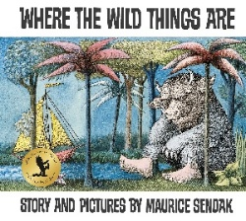 |  |  |  |  | DC Tale: The Enormous Turnip
Supporting texts |  |  |  | 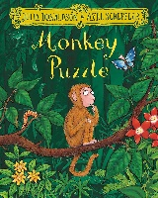 |  |  |  | 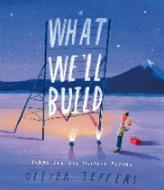 |  |  |  |  |  | 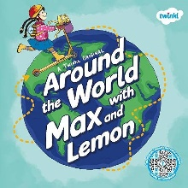 |  |  | 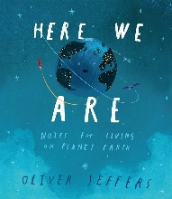 |  |  |  |  | 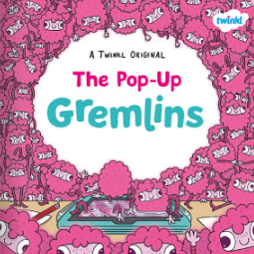 |  |  |  |  | 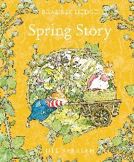
Spring 2 – Where are we?
English  Drawing Club |  |  | DC Book: 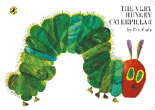 |  |  |  | DC Tale: The Runaway Pancake |  |  | DC cartoon:  Mr Benn Zookeeper |  |  |  |  | DC Book:  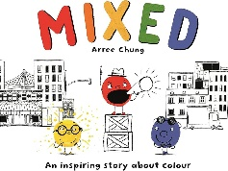 |  |  |  | DC Tale:  Goldilocks and the Three bears |  |  |  | DC cartoon: Hey Dugee The Honey Badge |  |  |  |  | DC Book:  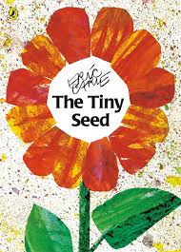
Supporting texts |  |  | 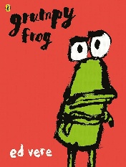 |  |  |  | 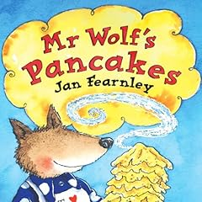 |  |  | 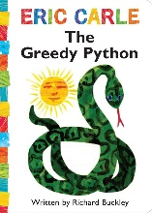 |  |  |  |  | 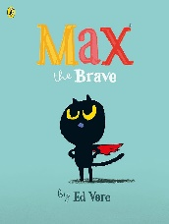 |  |  |  | 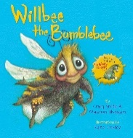 |  |  |  | 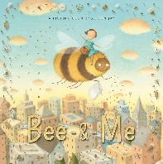 |  |  |  |  | 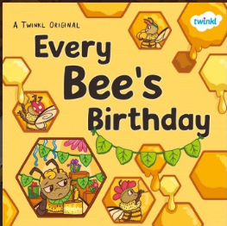
Summer 1 – Why are Bees Important?
English  Drawing Club |  | DC Tale: Jack and the Beanstalk |  |  |  |  |  |  |  |  |  | DC cartoon: Bananman |  |  |  |  |  | DC Book: 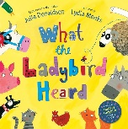 |  |  |  |  |  |  | Recount – farm trip
Supporting texts |  | 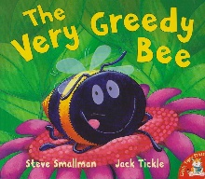 |  |  |  |  |  |  |  |  |  | 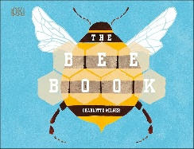 |  |  |  |  |  | 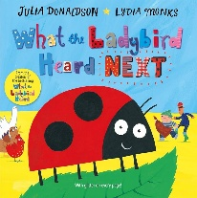 |  |  |  |  |  |  | 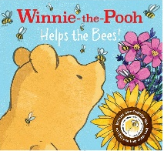
Summer 2 – How have I changed since starting school?
English  Drawing Club |  |  |  | DC Tale:  The Little Red Hen |  |  |  | DC Book:  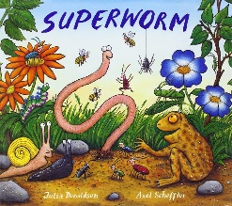 |  |  |  |  |  | DC Tale:  Chicken Licken |  |  | DC cartoon:  Wacky Races |  |  |  |  | DC Book:  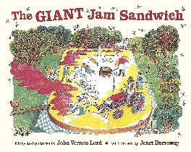 |  |  |  |  | DC Tale: The Magic Porridge Pot
Supporting texts |  |  |  | 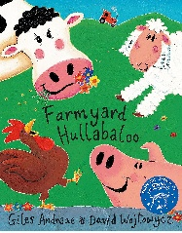 |  |  |  | 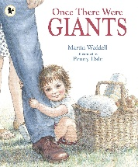 |  |  |  |  |  | 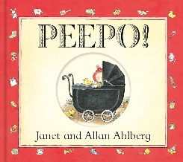 |  |  | 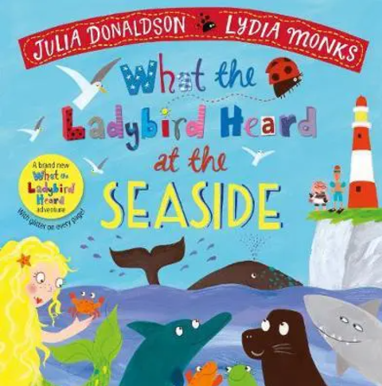 |  |  |  |  | 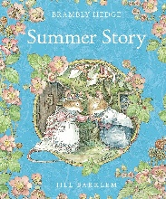 |  |  |  |  | 